Derivation of typical invertebrate assemblages

25.08.20

Jonathan Jupke

What is the optimal taxonomical level?

One result of the last progress review was that the taxa that make up the typical assemblages (TA) could be on different taxonomic levels (species, genus, family, …). We should include taxa that are typically represented at higher taxonomical levels at those levels (e.g. *Oligochaetes* at subclass level) and taxa whose taxonomy is usually highly resolved at higher levels. Thus, the question arises: given a dataset, what is the optimal taxonomical level to represent a specific taxon?

To establish the optimal level, we used a hierarchical approach. First, we removed all observations from Phyla and Classes that were not present in all data sets. We assumed that these represented differences in sampling rather than in communities. That left us with the classes Clitellata (Annelida), Insecta, Malacostraca (Arthropoda), Bivalvia and Gastropoda (Mollusca).

In the following higher taxonomic level refers to levels that are resolved more highly, i.e. species is the highest taxonomic level and kingdom the lowest. We inspected each higher level (subclass, order, family, genus) and calculated the percentage of observations that are represented at each level. For example, 4.12% of observations from the order *Lepidoptera* are at the species level, 74.77% at the genus level, 7.75% at the family level, and 13,35% at the order level. Now given a threshold X which is to be determined, we would call a taxon optimally represented at a certain taxonomical level if less than X% are represented by higher levels. For example, *Lepidoptera* would be represented on order level if X > 4,12 + 74,77 + 7,75 = 86,64%. As there are no theoretical grounds on which to base such a threshold value we searched for noticeable patterns in the data (Figure 1). The most noticeable jump occurs between 85 and 86%. It occurs because for X > 86 *Chironomidae* are represented at the family level. Hence, we used 85% as threshold. Observations that were missed by this procedure, *e.g.* observations of *Chironomidae* at the family level, were included at their respective level.

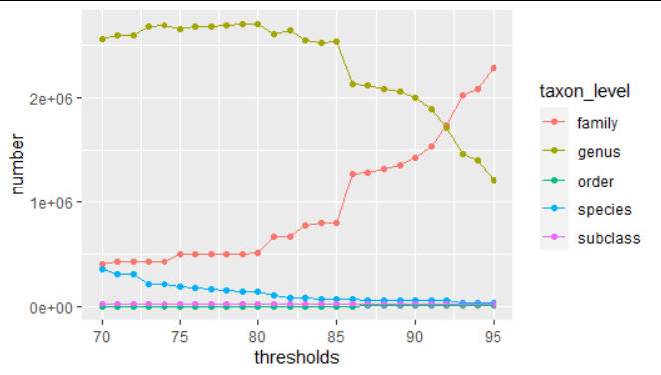

Figure 1: Number of observations at the different taxonomical resolutions as a function of the threshold value

Can we represent the stream types with those samples?

Whether a stream type is sufficiently sampled to derive meaningful TA was determined visually. Maps with all streams that belong to one stream type and all associated sampling sites are uploaded to the [Get Real Drive](https://drive.google.com/drive/folders/1xi3m9ZV38TjDYhaced7PEztP3rQoFdmY). The representativeness was graded in a three-tier system: good, medium, bad. Good representativeness indicates, that we have ample sampling locations, which are distributed evenly across the instances of a stream type that fall within the countries considered in GetReal. Bad representativeness indicates the opposite, i.e. few sites, and those are clustered spatially. A medium rating implies that we either have many sampling sites, but these only extend over parts of the countries or few sites that extend over most of the countries. Further analyses were conducted for all stream types with good and good or medium representation. More information on the river types is available in the [accompanying publication](https://www.sciencedirect.com/science/article/pii/S0048969719340203).

Good [n = 8]: 4,5,9,10,11,12,13,16

Medium [n = 7]: 1,2,3,8,14,15,18

Bad [n = 5]: 6,7,17,19,20

What is a typical assemblage?

As before TAs were derived based on a rule that considered

1. The probability of site *x* belonging to stream type *z* given species *y* is present (a measure of specificity, henceforth **A**)
2. The probability of species *y* being present given that site *x* belongs to stream type *z* (a measure of commonness, henceforth **B**)
3. The Species Indicator Value

The Species Indicator Value (Cáceres & Legendre, 2009; Dufrêne & Legendre, 1997) is the weighted product of **A** and **B** (Eqn. 1)

$\sqrt{IndVal}=\sqrt{A_{g}×B}=\sqrt{\frac{\frac{n_{p}}{N_{p}}}{Σ_{k=1}^{K}\frac{n_{k}}{N_{k}}}×\frac{n_{p}}{N_{p}}}$ Equation 1

where Np is the number of sites that belong to stream type p and np the number of occurrences of the focal species in sites of type p. K is the number of stream types. **A** is weighted by the total number of occurrences to account for unequal sample sizes. The statistical significance of the Indicator Value can be assessed with permutation-based pseudo-*p*-values, which we did with 999 permutations.

 Here, we are not interested in indicator species for each community, but TAs. Hence, simply continuing with those species that have a pseudo-*p-value* below some significance level would not serve our purpose. A species that occurs at each site, across all stream types, highlights the difference: while it would not be indicative of any stream type (low specificity) it should be part of each TA. Hence, we need additional criteria to derive the TAs which can be based on **A**, **B**, and the pseudo-*p-value* of the indicator value. We used the following rules:

Species were considered typical if B > 0.25 or B > 0.2 and p < 0.05 or A > 0.8

Genera were considered typical if B > 0.5 or B > 0.33 and p < 0.05 or A > 0.95

Families were considered typical if B > 0.95 or B > 0.8 and p < 0.01 or A > 0.99

Note that there was no systematic optimization used to define these thresholds. Such procedures would require optimization criteria, but we are not aware of a criterion that would work in this context. We acknowledged that typical assemblages could be (i) very similar in composition or (ii) harbor strongly differing numbers of taxa. Thus, parametrizing the rules in a way that would (i) maximize dissimilarity between assemblages or (ii) maximize the mean assemblage richness would not lead to what we consider a typical assemblage. It would be possible to try a cross-validation-type approach where each taxon is scored based on the number of random-site-subsets it is included in, but such an approach would also entail making essentially arbitrary numerical assumptions. We think the use of subjectively defined thresholds is justified, as long as they are clearly and openly communicated, to be what we define as “typical assemblages”.

However, we conducted a sensitivity analysis to see how much varying the parameters of the rules would alter the results. We altered the threshold values of A and B. The rules above contain two distinct B Threshold: B1 which does not consider the pseudo-*p­*-value (B > 0.25 for species) and B2 which does take the pseudo-*p­*­-value into account (B > 0.2 and p < 0.05). In the following simulations, the B2 was always taken to be 25% below B1. Henceforth, when referring to the threshold for B, we refer to B1. For species, we varied the threshold for B in ten steps between 0.10 and 0.75 and that for A in ten steps between 0.5 and 1.0. For lower taxonomic levels these thresholds were raised. For genera, the threshold values of A and B were raised by a factor of 1.25 and 2 respectively. All levels above and including families were grouped in “families or lower” (fol). For fol, the thresholds were raised by factors of 1.5 and 3 respectively. The taxon richness and uniqueness scores of each TA were computed for all 100 combinations of these parameters and each taxonomic level.

Please note that results are only shown and discussed for the non-redundant TAs (see the next section). Taxa richness decreased with increasing A and B threshold (Figure 2), while the uniqueness scores increased with B thresholds but decreased with A thresholds (Figure 3). Uniqueness scores decreased noticeably with very high A thresholds (> 0.9), indicating that taxa that are specific to certain river types are an important driver of TA differentiation. Note that graphs are only shown for all taxa levels combined. Plots for each taxon level separately are available in the [GetReal Drive](https://drive.google.com/drive/folders/1Gtm5ah9uouZmmi-Ti7l5dOJHlNvVUEma). However, the general patterns visible in Figure 2 and Figure 3, hold for them as well.

Redundancy in typical assemblages

We assessed to which degree the different TAs overlap (Table 1). The degree of overlap is the percentage of taxa in a TA that is also present in the most similar (largest overlap) TA.

Table 1: Redundancy between TAs

|  |  |  |
| --- | --- | --- |
| River type | Most similar river type(s) | Degree of overlap |
| RT01: Very Large Rivers | RT2+4 | 25 % |
| RT02: Lowland, siliceous, medium-large | RT3 | 88.2 % |
| RT03: Lowland, siliceous, very small-small | RT2 | 68.2 % |
| RT04: Lowland, calcareous or mixed, medium-large | RT3 | 45.8 % |
| RT05: Lowland, calcareous or mixed, very small-small | RT4 | 83.3 % |
| RT08: Mid-altitude, siliceous, medium-large | RT10 | 77.8% |
| RT09: Mid-altitude, siliceous, very small-small | RT8 | 76.5 % |
| RT10: Mid-altitude, calcareous or mixed, medium-large | RT11+18 | 65.2 % |
| RT11: Mid-altitude, calcareous or mixed, very small-small | RT10 | 88.2 % |
| RT12: Mid-altitude, organic and siliceous, very small-large | RT9 | 50.0 % |
| RT13: Mid-altitude, organic and calcareous/mixed | RT2 | 87.5 % |
| RT14: Highland (all Europe), siliceous, incl. organic (humic) | RT16+18 | 69.2 % |
| RT15: Highland (all Europe), calcareous/mixed | RT16 | 85.7 % |
| RT16: Glacial rivers (all Europe) | RT9+10+11+15 | 57.1 % |
| RT18: Mediterranean, mid-altitude, medium-large | RT10 | 55.6 % |

Again, choosing a threshold above which we consider two assemblages to be redundant is somewhat arbitrary. We proceeded with 75% but are open to other suggestions. This threshold leads to five redundant assemblages. Most are two river types that only differ in river size: RT02 and 03, 04 and 05, 08 and 09, as well as 10 and 11. The only exception is the combination of RT15 and 16. Both are high altitude river types that occur mainly in southern Europe, which differentiates them from the northern high altitude rivers in RT14. RT13 is also redundant with RT02 and 03 however joining it with these two river types led to a drastically reduced number of taxa in the TA, when compared to that of the combined river type RT02_03. Since RT13 represents an exceedingly rare river type we decided to omit it from the analysis and proceed with RT02_03 instead of RT02_03_13.

The new TAs resulted in overall lower degrees of overlap, none of which exceeds the 75% threshold. The largest overlaps were between RT8_9 and RT10_11, with 70%.

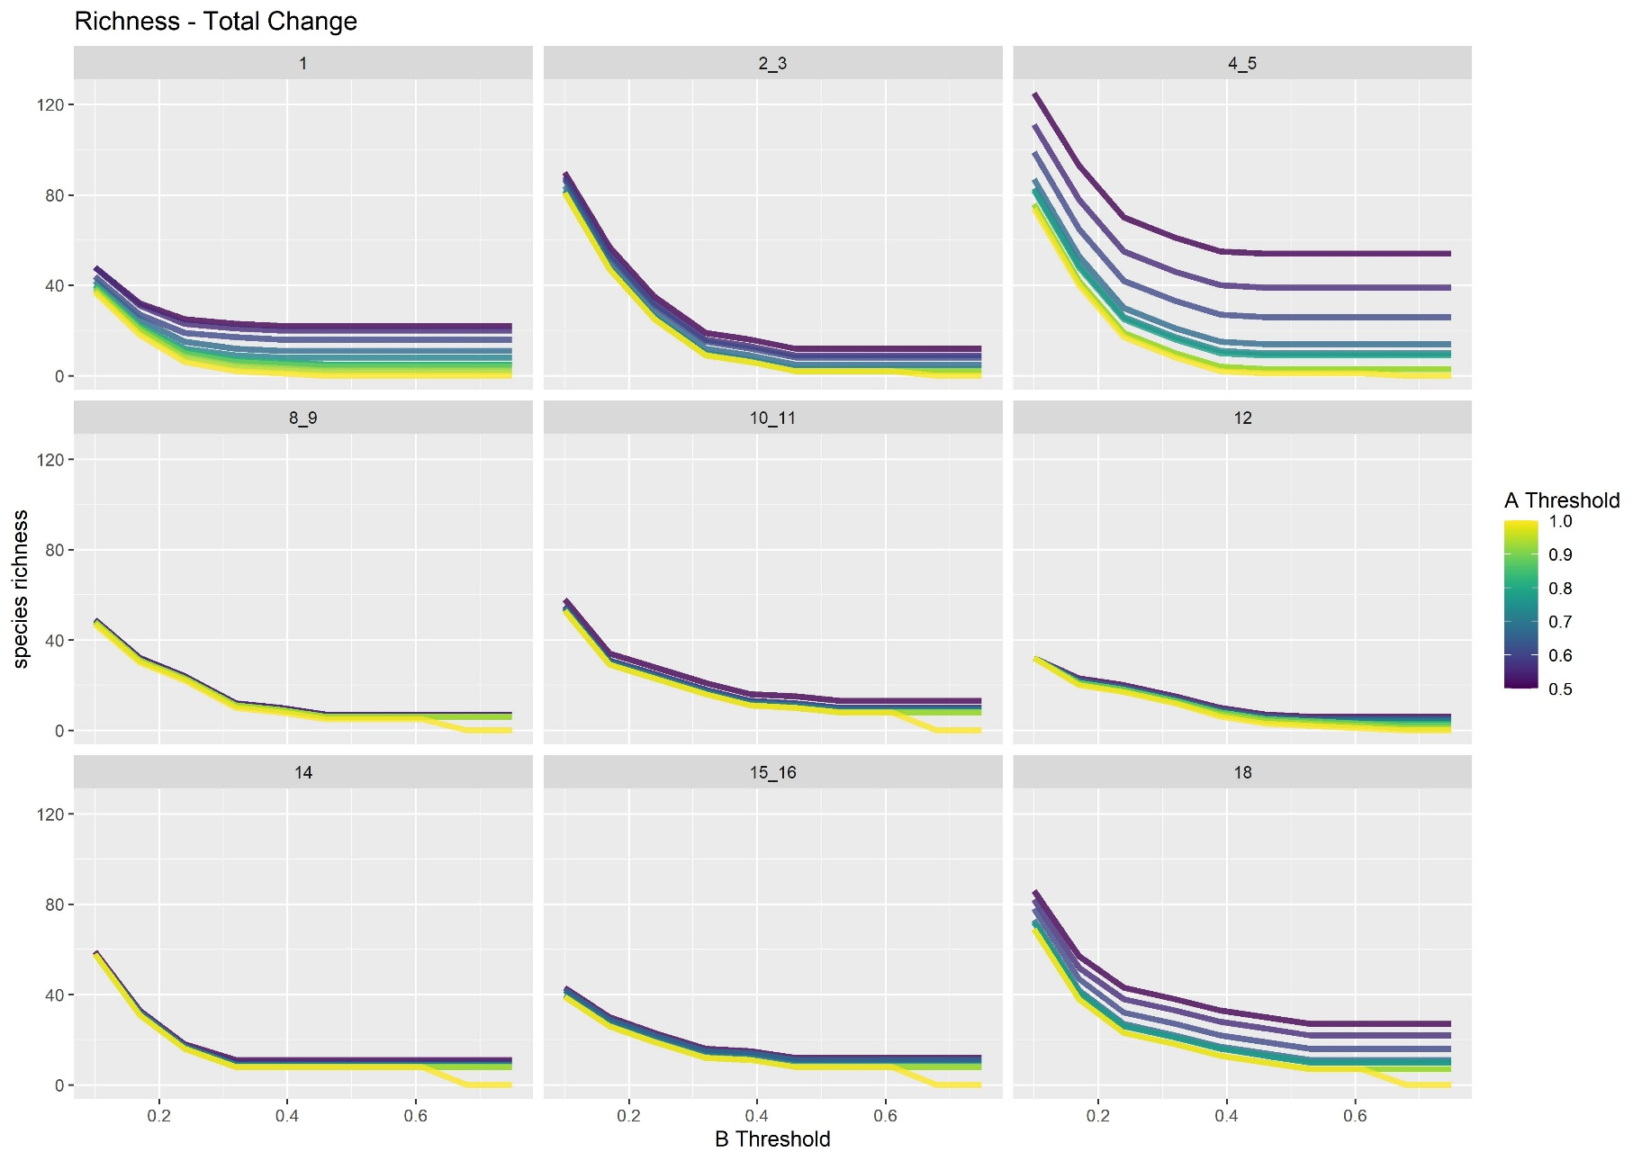

Figure 2: Changes in taxa richness along a changing B threshold. Line color indicates the employed A threshold

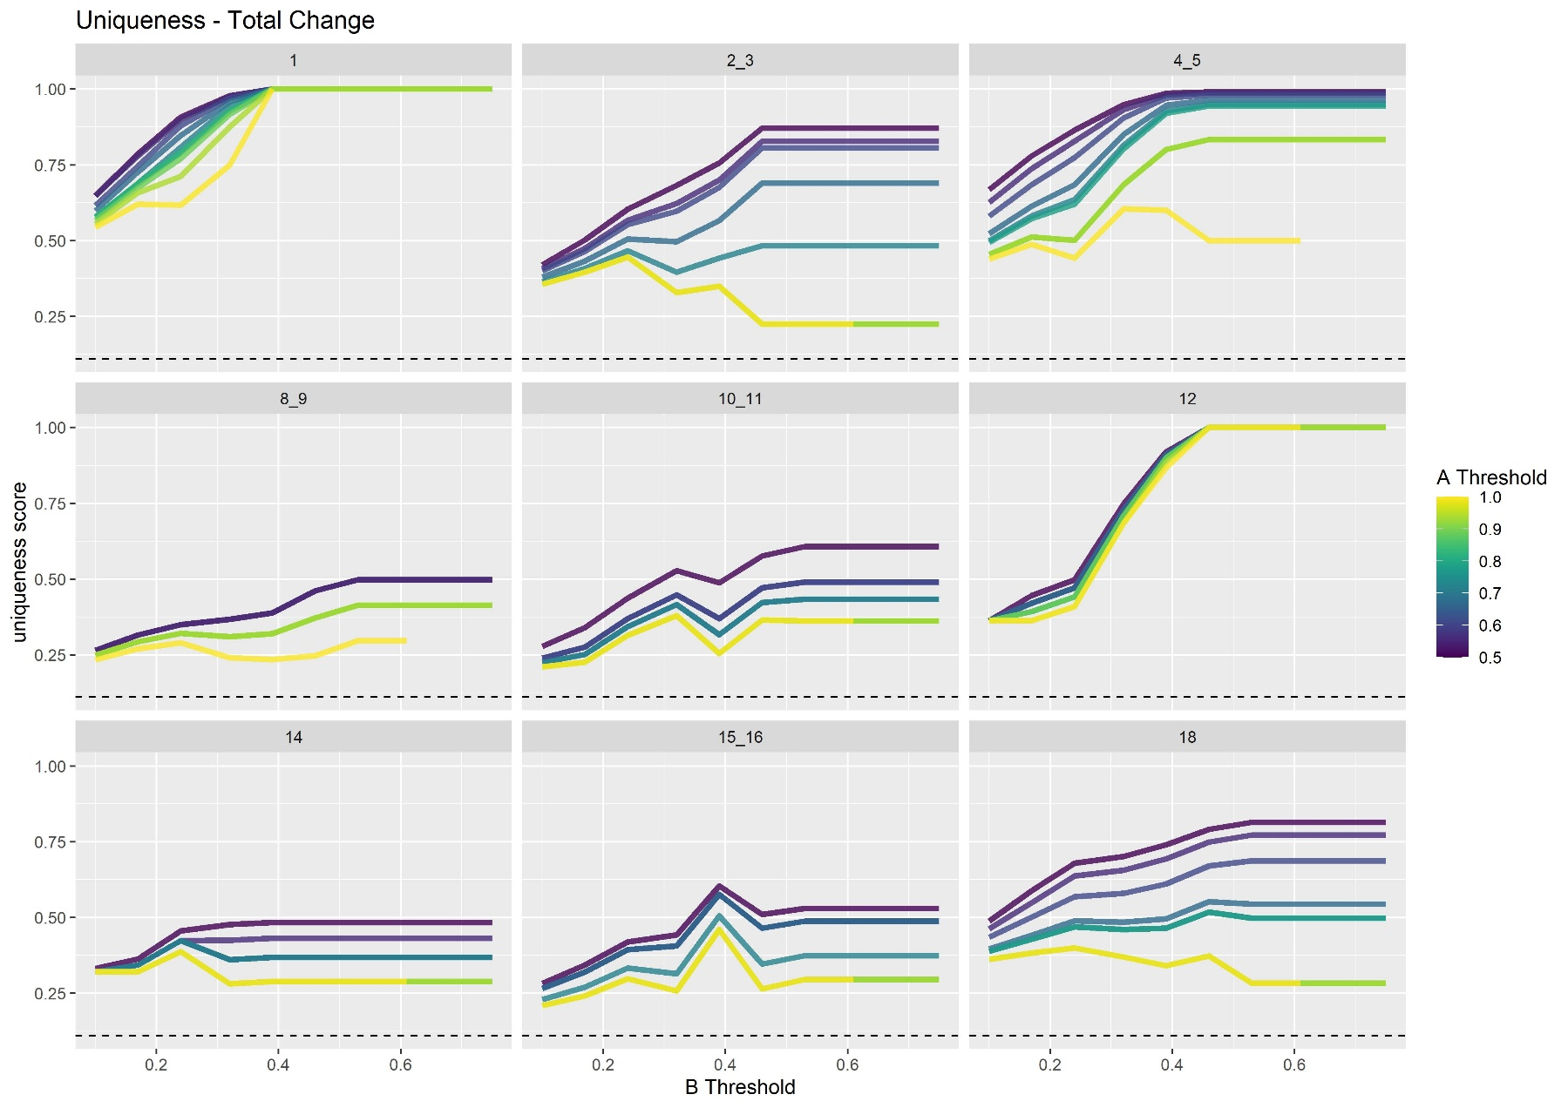

Figure 3: Changes in taxa uniqueness scores along a changing B threshold. Line color indicates the employed A threshold.

What do the typical assemblages look like?

In all TAs, genus is the prevalent taxonomic level (Figure 4). The numbers of species and fol are similar with both exceeding the other in four assemblages. The mean number of species was 3.2, mean number of genera 14.3, and the mean number of fol 2.4.

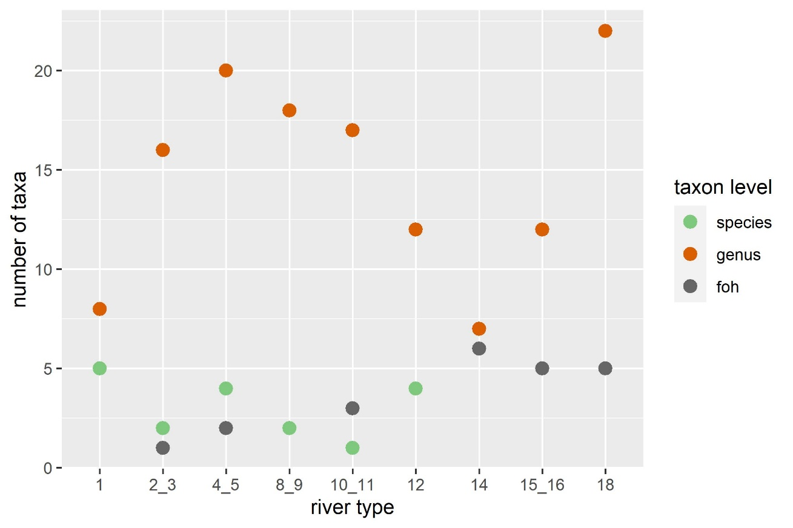

Figure 4: Numbers of taxa on each taxonomical level for all typical assemblages

We can express the uniqueness of a TA with the following score: Each taxon receives a taxon uniqueness score that is one divided by the number of TAs it occurs in. For each river type, we sum the taxon scores of all taxa up and divide it by the number of taxa in the river type’s TA. If all taxa in the TA are unique to that TA the score is one. If all species occur in one other TA the score is 0.5. The minimal score depends on the number of TAs, as it is 1 divided by that number and it signals that all species in that TA occur in all other TAs. These scores are shown in Figure 5. The dashed horizontal lines indicate the minimum score for each representation level.

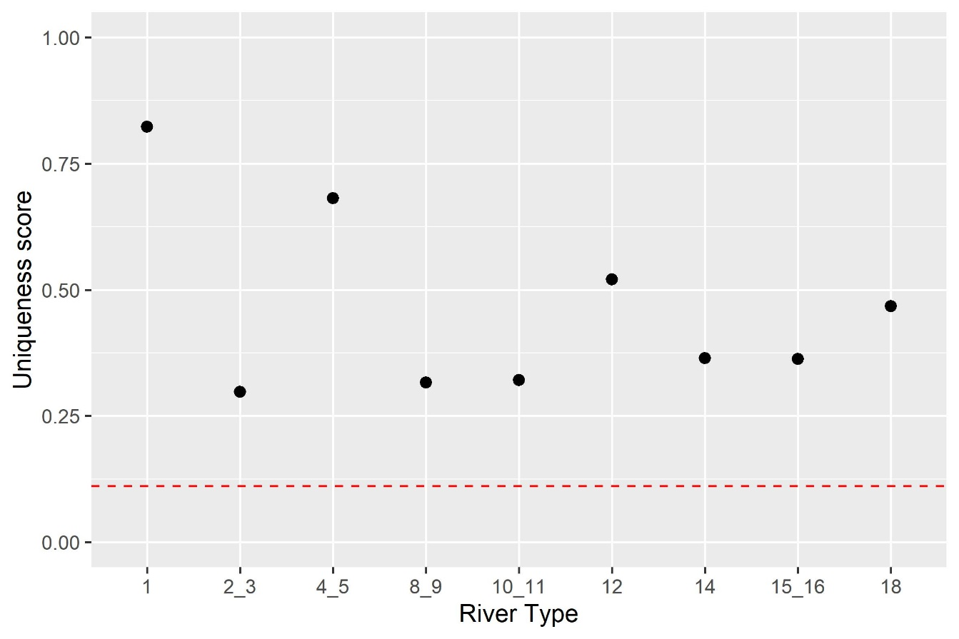

Figure 5: Uniqueness scores of all typical assemblages.

A Nonmetric multidimensional scaling (NMDS) of the data shows several plausible patterns (Figure 6). It is based on a custom distance metric which is based on the degree of overlap between assemblages. Most similar are RT10_11 and RT18, which have many close sites in southern France. The three assemblages RT2_3 (lowland siliceous), 8_9 (mid-altitude siliceous), and 15_16 (high altitude) are approximately as similar to each other, as they are to RT10_11 and RT18. Four assemblages are more distinct from this central cluster. RT1 (very large streams) has the least overlap with the other assemblages. RT4_5 are lowland calcareous or mixed rivers takes a middle position between lowland siliceous (2+3) and mid-altitude calcareous or mixed (10_11) and is very distinct from high altitude rivers and mid-altitude organic and siliceous (RT12) rivers. In general, one can see a gradient from higher to lower altitudes from the upper right to the lower left/middle of the plot. It is surprising to see how similar RT12 and RT15_16 seem to be, given the large geographic distance between sampling sites (see [maps in GetReal Drive](https://drive.google.com/drive/folders/1xi3m9ZV38TjDYhaced7PEztP3rQoFdmY)).

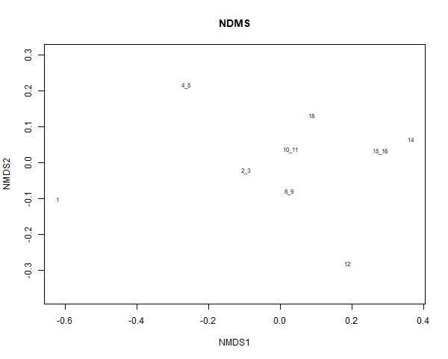

Figure 6: Non-metric multidimensional scaling of Jaccard distances between typical assemblages

Typical assemblages

Below we list the different taxa that belong to the typical assemblages.

RT01 - Very Large rivers

*Borysthenia naticina, Esperiana esperi, Hippolyte desmaresti, Microcolpia daudebartii, Obesogammarus obesus, Ancylus, Caenis, Chelicorophium, Corbicula, Dikerogammarus, Echinogammarus, Jaera, Potamopyrgus*

RT02_03 - Lowland siliceous, very small - large

*Peregriana peregra, Serratella ignita, Ancylus, Baetis, Caenis, Dicranota, Ecdyonurus, Elmis, Gammarus, Hydropsyche, Lepidostoma, Limnius, Oulimnius, Pisidium, Polycentropus, Potamopyrgus, Rhithrogena, Rhyacophila, Ameletidae*

RT04_05 - Lowland calcareous, very small - large

*Metreletus balcanicus, Odhneripisidium moitessierianum, Peregriana peregra, Serratella ignita, Ancylus, Asellus, Baetis, Caenis, Calamoceras, Cataclysta, Elmis, Elophila, Erpobdella, Gammarus, Glossiphonia, Harnischia, Hydropsyche, Ilyocoris, Micropsectra, Oulimnius, Pisidium, Potamopyrgus, Ranatra, Sphaerium, Unionidae, Viviparidae*

RT08_09 - Mid-altitude siliceous, very small-large

Isogenus nubecula, Serratella ignita, Amphinemura, Ancylus, Baetis, Dicranota, Ecdyonurus, Elmis, Ephemera, Gammarus, Hydraena, Hydropsyche, Isoperla, Leuctra, Limnius, Odontocerum, Polycentropus, Protonemura, Rhithrogena, Rhyacophila

RT10_11 - Mid-altitude, calcareous or mixed, very small - large

Serratella ignita, Ancylus, Baetis, Ecdyonurus, Elmis, Ephemera, Esolus, Gammarus, Hydraena, Hydropsyche, Hydroptila, Leuctra, Limnius, Odontocerum, Pisidium, Rhithrogena, Rhyacophila, Riolus, Chironomidae, Micronectidae, Simuliidae

RT12 – Mid-altitude, organic and siliceous

Ameletus inopinatus, Diura nanseni, Kageronia fuscogrisea, Nigrobaetis niger, Amphinemura, Baetis, Dicranota, Elmis, Ephemerella, Heptagenia, Isoperla, Lepidostoma, Leptophlebia, Leuctra, Polycentropus, Rhyacophila

RT14 – Highland, siliceous, incl. organic (humic)

Baetis, Ephemerella, Heptagenia, Hydraenida, Hydropsyche, Leuctra, Rhyacophila, Chironomidae, Empididae, Limnephilidae, Limoniidae, Oligochaeta, Simuliidae

RT15_16 – Highland, calcareous/mixed and glacial rivers

*Baetis, Ecdyonurus, Elmis, Epeorus, Hydraena, Hydropsyche, Isoperla, Leuctra, Nemoura, Protonemura, Rhithrogena, Rhyacophila, Chironomidae, Limnephilidae, Limoniidae, Oligochaeta, Simuliidae*

RT18 - Mediterranean mid-altitude, medium-large, perennial

*Baetis, Caenis, Calopteryx, Ecdyonurus, Elmis, Ephemerella, Esolus, Gammarus, Hydropsyche, Hydroptila, Hydroscapha, Leuctra, Limnius, Onychogomphus, Oulimnius, Polycentropus, Potamopyrgus, Procambarus, Psychomyia, Rhyacophila, Riolus, Sympecma, Chironomidae, Empididae, Lestidae, Oligochaeta, Simuliidae*

# References

Cáceres, M. de, & Legendre, P. (2009). Associations between species and groups of sites: inindices and statistical inference. *Ecology*, *90*(12), 3566–3574. https://doi.org/10.1890/08-1823.1

Dufrêne, M., & Legendre, P. (1997). SPECIES ASSEMBLAGES AND INDICATOR SPECIES: THE NEED FOR A FLEXIBLE ASYMMETRICAL APPROACH. *Ecological Monographs*, *67*(3), 345–366.